Git Lab Task 1

1. Check Git installation
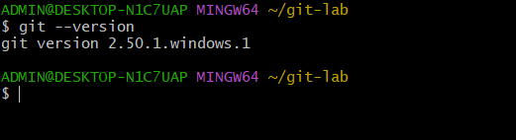

2.Configure it
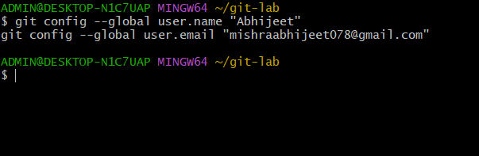

3.Create a local Project
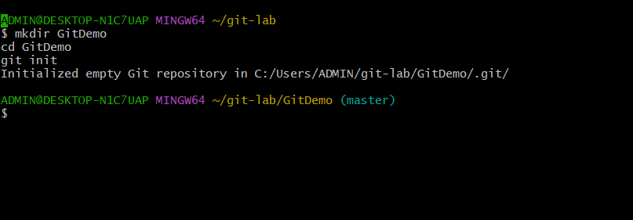

4. Create a file

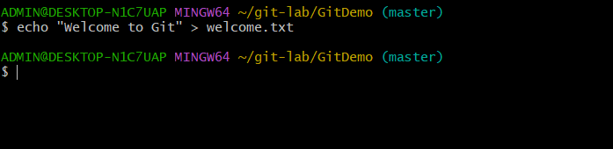

5. Check status
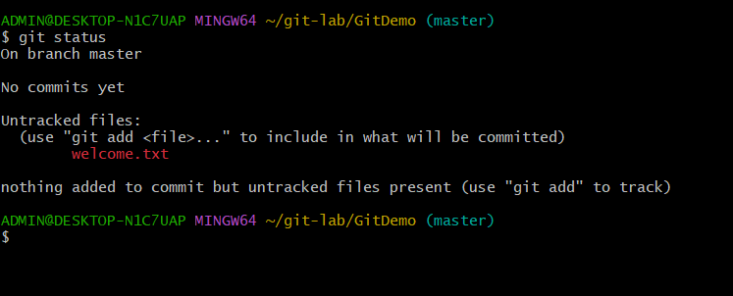

6. Add the file
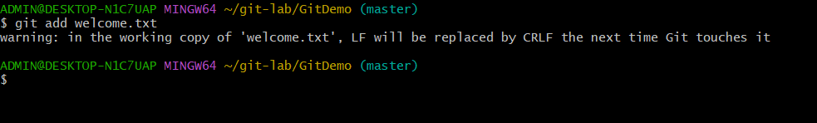

7.Commit
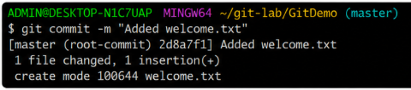

8.Connected Git Repository
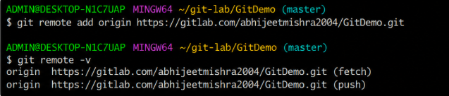

9.Push the Work
